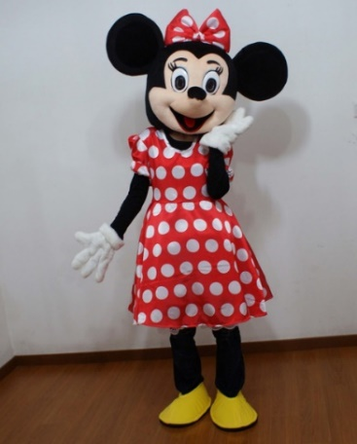
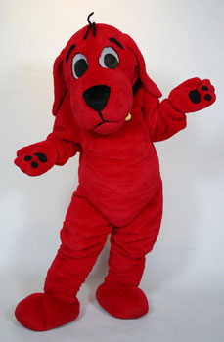
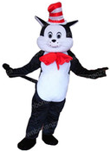

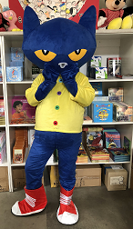
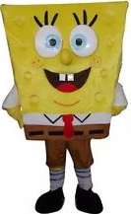
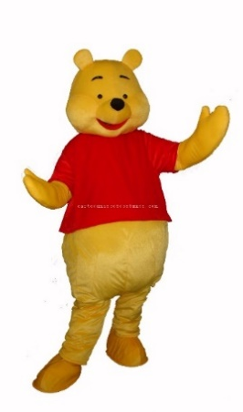

RIFSoCal is fortunate to be able to offer seven different character costumes for free rental available to all schools that are able to pick them up and drop them off within the agreed upon timeframe.

The Cat in the Hat, The Big Red Dog, Minnie, Pooh, Pete the Cat, Sponge Bob and Curious George are great additions to any Motivational Reading Event!

If you are interested in reserving one of the characters, please call the warehouse at
323-890-0876 to discuss their availability and schedule a pick-up and drop-off time.

